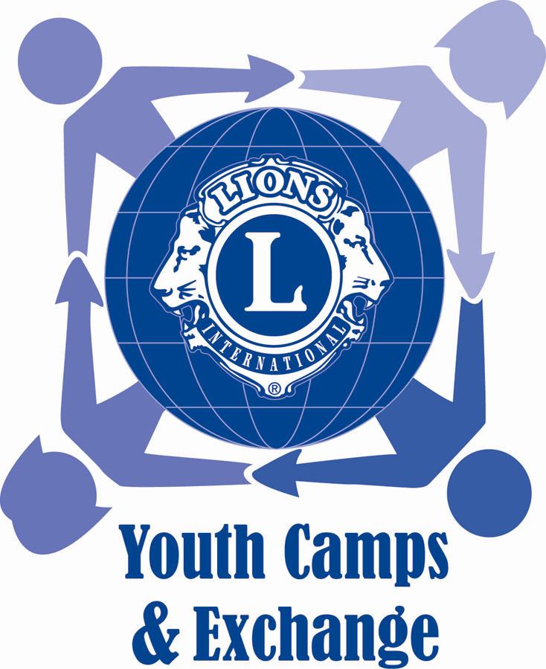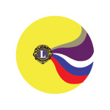

“Catch the Rainbow”



Lions Clubs International

District 129 – Slovenia

Lions Youth Exchange

District Chairperson

Marko Kužner

Grčarjeva 12

3000 Celje

Slovenia

youth.exchange@lions.si

|  |  |
| --- | --- |
|  | +386 41 608 350 |

Incoming youth:

Ema Trobentar

Grčarjeva 12

3000 Celje

Slovenia

[incoming.youth.exchange@lions.si](mailto:incoming.youth.exchange@lions.si)

+386 40 770 103

Application deadline: 15.3.2025

Dear Lions friends,

It is my great pleasure to announce that Lions clubs of District 129 Slovenia will sponsor the 27th Lions International Youth Camp “Catch the Rainbow” held in Slovenia.

We expect young people from different countries. It will be great opportunity for them to make new friends, promote peace through Lionism and learn about Slovenia.

We, Lions of Slovenia, would be very happy if we were able to host your youths in our country.

Marko Kužner,

Youth Exchange Chairperson

District 129 - Slovenia

Slika, ki vsebuje besede skica, rokopis, besedilo, črna

Opis je samodejno ustvarjen

Introduction

Participants will:

* Learn about Slovenia by visiting different regions and towns, get familiar with Slovenian history and culture, cuisine,…
* Participate in sport activities: hiking, rafting, swimming, beach volley.
* Youth Exchange students represent their countries at “International Evening”

Other information

Activities

Exchange period

Program is open for:

**Male and Female; 18 – 24 years old**

Fee for transportation & insurance:

**150,00 EUR**

All other costs will be covered by Lions District 129 – Slovenia.

Official language:

**English**

Other:

Smoking and alcohol are restricted, (allowed in reasonable quantities).

27th Lions Youth Camp of District 129 Catch the Rainbow”:

**Will be held in: Slovenia**

**Between: 25 July and 4 August 2025**

Family hosting for participants from **European countries will be arranged for 1 week before camp**.

Family hosting for participants from the **Non- European countries will be arranged for 2 weeks before or after the camp.**

Lions Youth Exchange Program – Catch the Rainbow

Lions Youth Exchange Program – District 129 – Slovenia – Acceptance letter

Page 3

Lions Youth Exchange Program – District 129 – Slovenia – Acceptance letter

Page 3